1. **sql数据库**

**ER 图**

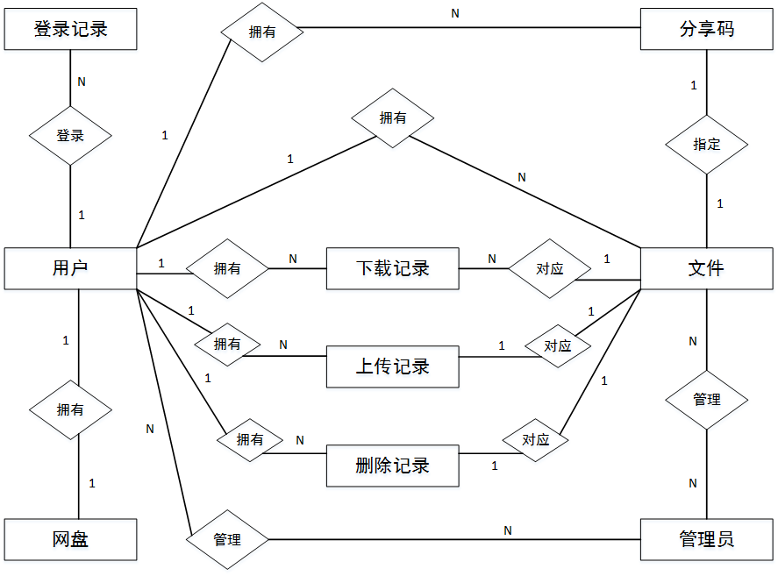

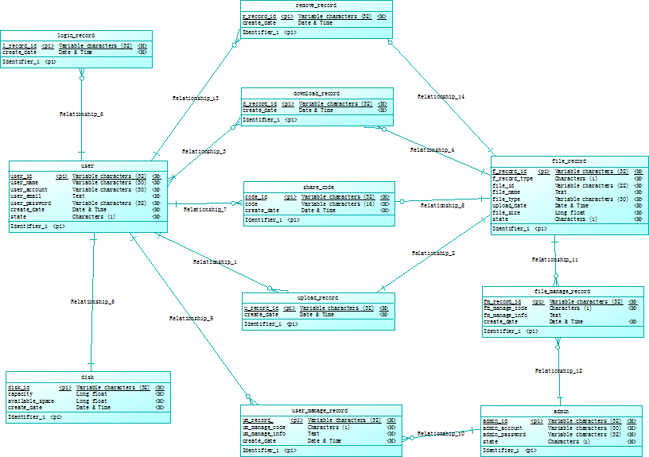

1. **用户表 user**

|  |  |  |  |  |
| --- | --- | --- | --- | --- |
| **字段** | **类型** | **NULL** | **KEY** | **备注** |
| **user_id** | **varchar(32)** | **NO** | **PRI** | **用户id** |
| **user_name** | **varchar(60)** | **NO** |  | **用户姓名** |
| **user_account** | **varchar(60)** | **NO** |  | **用户账户** |
| **user_email** | **text** | **NO** |  | **用户邮箱** |
| **user_password** | **varchar(32)** | **NO** |  | **用户密码** |
| **create_date** | **datetime** | **NO** |  | **创建日期** |
| **state** | **char(1)** | **NO** |  | **用户状态码** |

**（2）登录记录表 login_record**

|  |  |  |  |  |
| --- | --- | --- | --- | --- |
| **字段** | **类型** | **NULL** | **KEY** | **备注** |
| **l_record_id** | **varchar(32)** | **NO** | **PRI** | **记录id** |
| **user_id** | **varchar(32)** | **NO** | **FK** | **用户id** |
| **login_date** | **datetime** | **NO** |  | **登录时间** |
| **login_ip** | **varchar(20)** | **NO** |  | **用户登录ip** |

**（3）文件记录表 file_record**

|  |  |  |  |  |
| --- | --- | --- | --- | --- |
| **字段** | **类型** | **NULL** | **KEY** | **备注** |
| **f_record_id** | **varchar(32)** | **NO** | **PRI** | **记录id** |
| **f_record_type** | **char(1)** | **NO** |  | **文件记录类型** |
| **file_id** | **varchar(22)** | **NO** |  | **文件id** |
| **file_name** | **text** | **NO** |  | **文件名** |
| **file_type** | **varchar(20)** | **NO** |  | **文件类型** |
| **file_size** | **double** | **NO** |  | **文件大小** |
| **upload_date** | **datetime** | **NO** |  | **上传时间** |
| **state** | **char(1)** | **NO** |  | **文件状态码** |

**（4）用户网盘表 disk**

|  |  |  |  |  |
| --- | --- | --- | --- | --- |
| **字段** | **类型** | **NULL** | **KEY** | **备注** |
| **disk_id** | **varchar(32)** | **NO** | **PRI** | **网盘id** |
| **user_id** | **varchar(32)** | **NO** | **FK** | **用户id** |
| **capacity** | **double** | **NO** |  | **空间容量** |
| **available_size** | **double** | **NO** |  | **可用容量** |
| **create_date** | **datetime** | **NO** |  | **创建日期** |

**（5）下载记录表 download_record**

|  |  |  |  |  |
| --- | --- | --- | --- | --- |
| **字段** | **类型** | **NULL** | **KEY** | **备注** |
| **d_record_id** | **varchar(32)** | **NO** | **PRI** | **记录id** |
| **user_id** | **varchar(32)** | **NO** | **FK** | **用户id** |
| **f_record_id** | **varchar(32)** | **NO** | **FK** | **文件记录id** |
| **download_date** | **datetime** | **NO** |  | **下载时间** |

**（6）上传记录表 upload_record**

|  |  |  |  |  |
| --- | --- | --- | --- | --- |
| **字段** | **类型** | **NULL** | **KEY** | **备注** |
| **u_record_id** | **varchar(32)** | **NO** | **PRI** | **上传记录id** |
| **user_id** | **varchar(32)** | **NO** | **FK** | **用户id** |
| **f_record_id** | **varchar(32)** | **NO** | **FK** | **文件记录id** |
| **upload_date** | **datetime** | **NO** |  | **上传时间** |

**（7）删除记录表 remove_record**

|  |  |  |  |  |
| --- | --- | --- | --- | --- |
| **字段** | **类型** | **NULL** | **KEY** | **备注** |
| **r_record_id** | **varchar(32)** | **NO** | **PRI** | **删除记录id** |
| **user_id** | **varchar(32)** | **NO** | **FK** | **用户id** |
| **f_record_id** | **varchar(32)** | **NO** | **FK** | **文件记录id** |
| **remove_date** | **datetime** | **NO** |  | **删除时间** |

**（8）文件共享表 share_code**

|  |  |  |  |  |
| --- | --- | --- | --- | --- |
| **字段** | **类型** | **NULL** | **KEY** | **备注** |
| **code_id** | **varchar(32)** | **NO** | **PRI** | **共享码id** |
| **code** | **varchar(16)** | **NO** |  | **共享码** |
| **user_id** | **varchar(32)** | **NO** | **FK** | **用户id** |
| **create_date** | **datetime** | **NO** |  | **创建时间** |

**（9）管理员表 admin**

|  |  |  |  |  |
| --- | --- | --- | --- | --- |
| **字段** | **类型** | **NULL** | **KEY** | **备注** |
| **admin_id** | **varchar(32)** | **NO** | **PRI** | **管理员id** |
| **admin_account** | **varchar(20)** | **NO** |  | **管理员账户** |
| **admin_password** | **varchar(32)** | **NO** |  | **管理员密码** |
| **state** | **char(1)** | **NO** |  | **账户状态** |

**（10）用户管理记录表 user_manage_record**

|  |  |  |  |  |
| --- | --- | --- | --- | --- |
| **字段** | **类型** | **NULL** | **KEY** | **备注** |
| **um_record_id** | **varchar(32)** | **NO** | **PRI** | **记录id** |
| **user_id** | **varchar(32)** | **NO** | **FK** | **用户id** |
| **admin_id** | **varchar(32)** | **NO** | **FK** | **管理员id** |
| **um_manage_type** | **char(1)** | **NO** |  | **操作类型** |
| **um_manage_info** | **text** | **YES** |  | **管理备注** |
| **create_date** | **datetime** | **NO** |  | **创建日期** |

**（11）文件管理记录表 file_manage_record**

|  |  |  |  |  |
| --- | --- | --- | --- | --- |
| **字段** | **类型** | **NULL** | **KEY** | **备注** |
| **fm_record_id** | **varchar(32)** | **NO** | **PRI** | **记录id** |
| **f_record_id** | **varchar(32)** | **NO** | **FK** | **文件记录id** |
| **admin_id** | **varchar(32)** | **NO** | **FK** | **管理员id** |
| **fm_manage_type** | **char(1)** | **NO** |  | **操作类型** |
| **fm_manage_info** | **text** | **YES** |  | **管理备注** |
| **create_date** | **datetime** | **NO** |  | **创建日期** |

1. **MongoDB数据库(GridFS)**

**集合files.files**

|  |  |
| --- | --- |
| **键** | **值类型** |
| **_id** | **ObjectId()** |
| **fileName** | **字符串** |
| **fileSize** | **数值** |
| **fileType** | **字符串** |
| **uploadDate** | **日期** |
| **length** | **数值** |
| **chunkSize** | **数值** |
| **md5** | **字符串** |

**集合files.chunks**

|  |  |
| --- | --- |
| **键** | **值类型** |
| **files_id** | **Object_id** |
| **n** | **数值** |
| **data** | **字符串** |

**file_id:块所属文件的元信息**

**n：块在文件中的相对位置**

**data：块所包含的二进制数据**